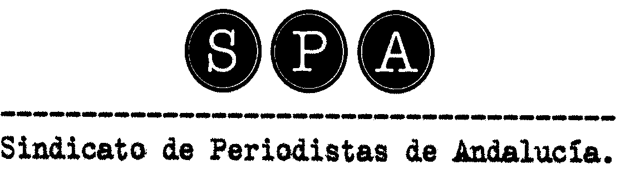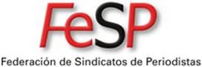

The Union of Journalists of Andalusia (SPA) announces the VIII International Journalist 'Julio Anguita Parrado' Awards, for the recognition of the trajectory of journalists committed to Human Rights
- The prize, worth 2,500 euros and a commemorative sculpture is supported by the Córdoba City Council and the collaboration of the University of Cordoba.
- The deadline for nominations is March 6, 2015.
The Union of Journalists of Andalusia (SPA) and the Spanish Federation of Journalists,FeSP, announces the VIII International Journalism 'Julio Anguita Parrado' Awards, in memory of Cordoba journalist killed in Iraq on April 7, 2003. The award, worth 2,500 euros and a commemorative sculpture, is sponsored by the Córdoba City Council, the collaboration of the University of Córdoba, the Jewellery Park and the School of Jewellery of Córdoba.

The aims of the "Julio Anguita Parrado Awards" is to recognize journalists of any nationality with a brilliant career, committed to the defense of human rights or journalistic organizations or entities who operate mainly in areas of armed conflict or particularly violent.

The deadline for nominations opens on January 28 and will close on March 6, 2015.

The jury of the eighth edition of 'Julio Anguita Parrado' Awards consists of journalists Juan Cruz, attached to the direction of El País; Rosa Maria Calaf, journalist long career as a correspondent for TVE; Pilar Vergara, director of information services of Canal Sur TV; Maria del Mar Ramirez, Dean of the School of Communication at the University of Seville, and Luis Medina, a professor at the University of Córdoba. As a representative of the family will be in the jury Julio Anguita González and by the Union of Journalists of Andalusia its general secretary, Lola Fernandez Palenzuela, who will act as secretary of the jury, with voice but no vote.

Call guidelines

The aims of the "Julio Anguita Parrado Awards" is to recognize journalists of any nationality with a brilliant career, committed to the defense of human rights or journalistic organizations or entities who operate mainly in areas of armed conflict or particularly violent.
According to collect the bases, applications may be submitted by the Union of Journalists of Andalusia (SPA), the Spanish Federation of Journalists (FeSP) and other trade unions and professionals organizations of journalists and media workers, institutions or organizations that remain outside the journalistic space agreements or partnerships with the SPA or FeSP.

Nominations submitted must be accompanied by a proposed by candidate or organization journalist, and its curriculum and any written, graphic or audiovisual documentation or links to them, deemed appropriate for the accreditation of merit. Telephone and email address of the person or organization that has as deserving of the award must also be included.

Nominations for the eighth edition of 'Julio Anguita Parrado' Award must be sent by post or email to:
- Email: comunicacion@spandalucia.com
- Mail: International Journalism Julio Anguita Parrado Award. Union of Journalists of Andalusia (SPA). Hileras Street, 3rd F. 1. 18001 Granada-Spain.

The deadline for nominations is March 6, 2015. The jury's verdict will be announced during the month of March 2015 and the award ceremony will be held in the city of Córdoba on April 7th, 2015 .

The winners of the seven editions of the International Journalism 'Julio Anguita Parrado' Award were:

· In 2007, Eman Ahmad Hamas, Iraqi journalist and activist, founder of the Observatory against Invasion of Iraq.
· In 2008, Eduardo González Márquez, president of the Colombian Federation of Journalists and founder of the Solidarity Center of Journalists of the International Federation of Journalists.
· In 2009, Caddy Adzuba Furaha, a journalist with the Democratic Republic of Congo and member of the Association of Media Women in South Kivu / DRC and the Network of Women Journalists and Communicators of 'A speaker for Silence'. Príncipe de Asturias Award for Concord 2014.
· In 2010, Monica Bernabé Fernández, freelance journalist based in Afghanistan, a correspondent for various media, including the newspaper El Mundo, and founder and president of the Association of Human Rights in Afghanistan.
· In 2011, Gervasio Sánchez, photojournalist who has covered most of the armed conflicts of recent decades. Photojournalist recognized for coverage of so-called 'forgotten conflicts', Spanish media contributor and author of numerous books and photo exhibitions.
· In 2012, Sharira Amin, an Egyptian journalist freelance correspondent for CNN. He has worked for the Egyptian state television, Nile TV, where he practiced as deputy head when he resigned to join the movement activists from Tahrir Square.
· In 2013, Kostas Vaxevanis, Greek journalist who began his career in 1988 in the journal Rizospastis. Since 1991, he has covered all the crises of war throughout the world as a correspondent for MEGA TV channels and Greek national television.

SPA -Union of Journalists of Andalusia

http://www.spandalucia.com - comunicacion@spandalucia.com
http://www.facebook.com/spandalucia
http://www.twitter.com/SPA_Periodistas

